|  |  |
| --- | --- |
| **Control Limits for Control Charts** | |
| Process Mean |  |
| Process Standard Deviation |  |
| Process Range |  |

**Process Capability Indices**

|  |  |  |
| --- | --- | --- |
|  | Population Known | Population Unknown |
| ***Cp*** | Cp = (USL - LSL)/6*sigma | Chat(p) = (USL - LSL)/6*s |
| ***Cpk*** | Cpk = MIN[(USL-mu)/(3*sigma), (mu-LSL)/(3*sigma)] | Chat(pk) = MIN[(USL-m)/(3*s), (m-LSL)/(3*s)] |
| ***Cpm*** | Cpm = (USL-LSL)/{6*SQRT(s**2 + (mu-T)**2)} | Chat(pm) = (USL-LSL)/{6*SQRT(s**2 + (m-T)**2)} |

**Question 1A (Theory Questions)**

1. Differentiate common (or chance) causes of variation in the quality of process output from assignable (or special) causes.
2. Differentiate a stable process from an unstable process.
3. Other than applying the 3-sigma rule for detecting the presence of an assignable cause, what else do we look for when studying a control chart?
4. Describe how the output of a stable process can be improved. What actions do not improve a stable process, but rather, make the output more variable?
5. What is the purpose of maintaining control charts?
6. What is tampering in the context of process control?

**Question 1b**

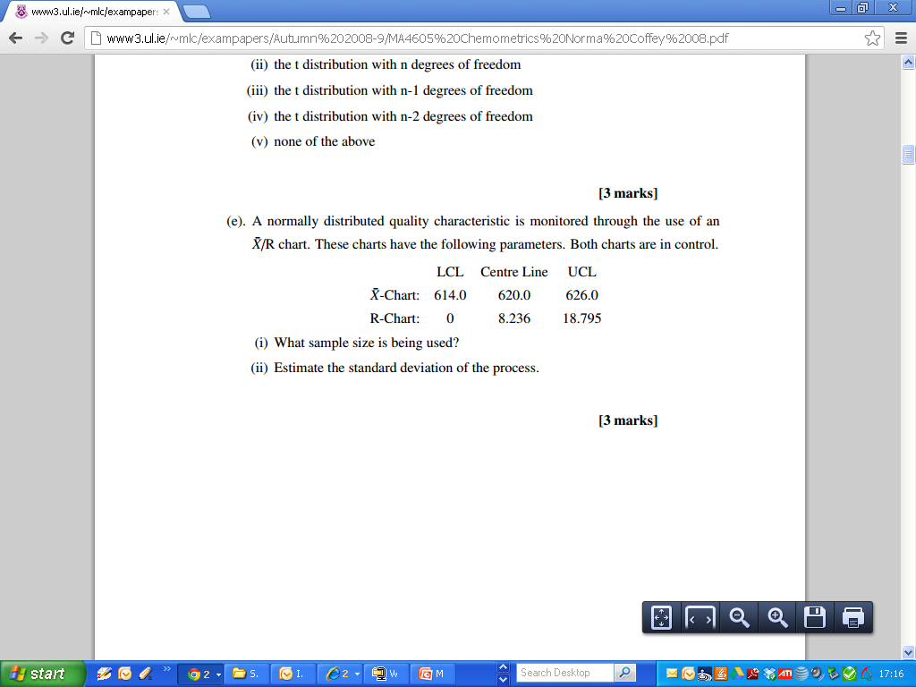

***(iii) Compute the control limits for the process standard deviation chart.***

**Question 2**

For the following x.bar chart, compute the control limits given that the following information

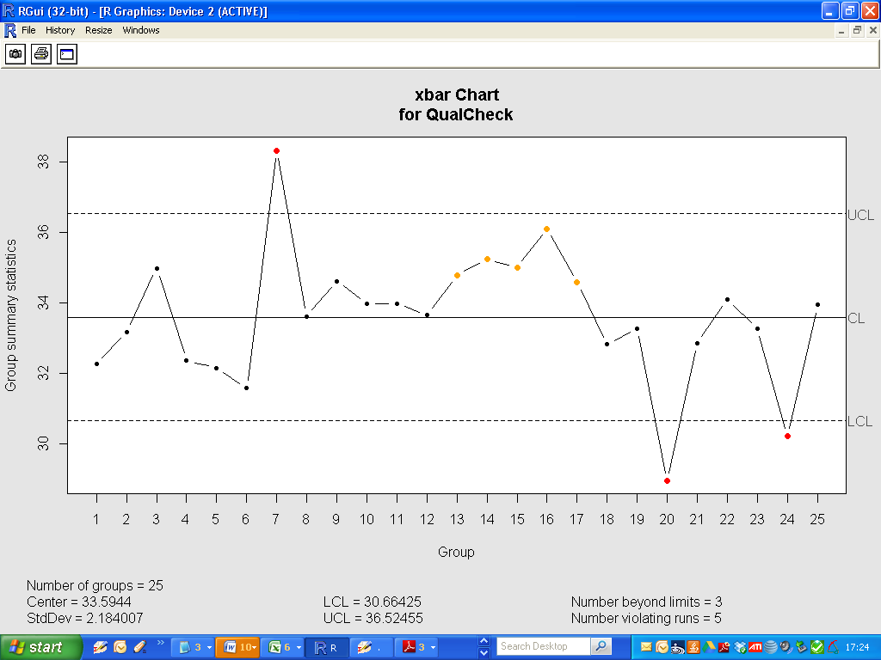

Sample size =5

Comment on the chart, with reference to two separate tests. Is the process on control?

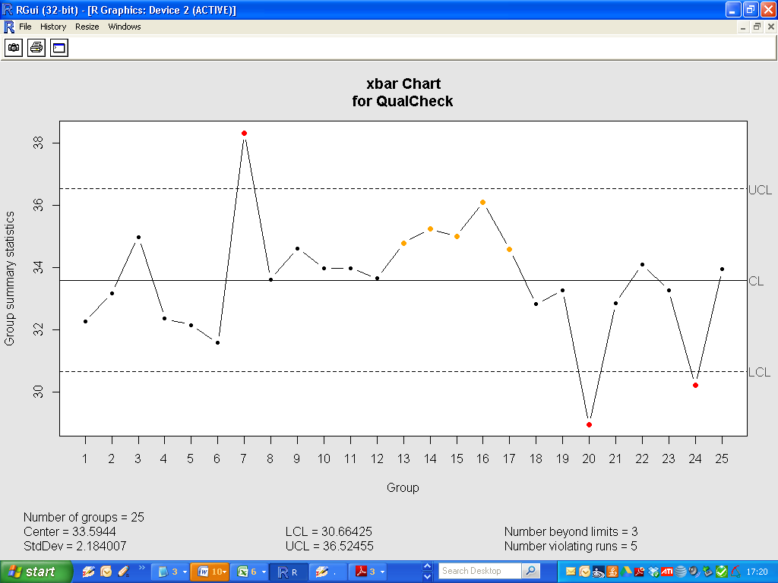

Question 3A

Suppose the specifications for the process state that the Lower and Upper Specification Levels are 25 and 40 respectively.

Determine the Process Capability Indices ***Cp*** and ***Cpk*** , commenting on the respective values.

Comment on the graphical output of the Process Capability Analysis.

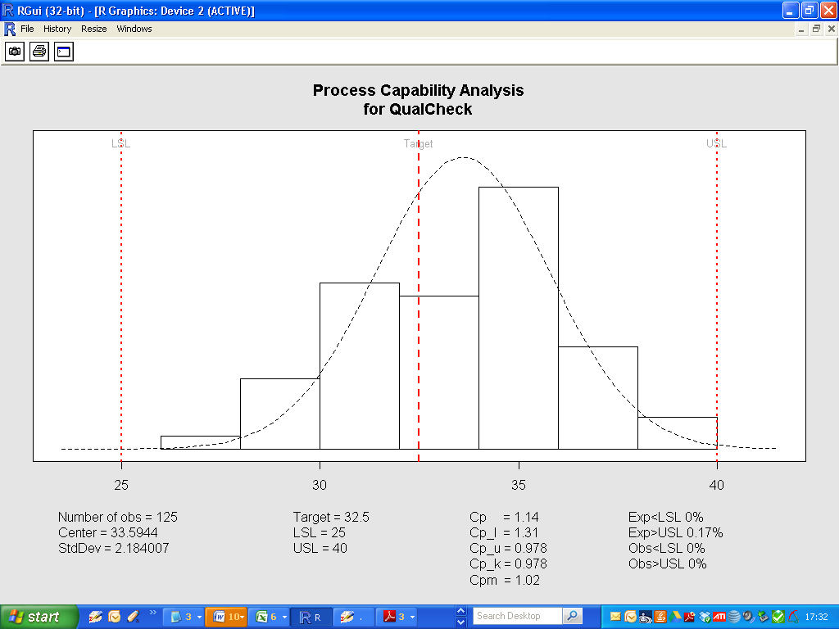

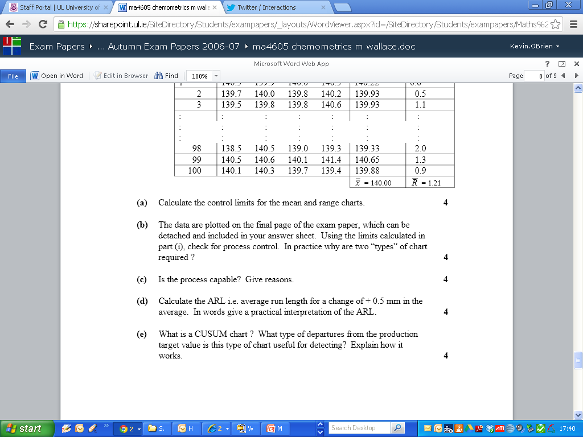

**Question 3B**

Suppose the specifications for the process state that the Lower and Upper Specification Levels are 30 and 36 respectively. Again determine the Process Capability Indices ***Cp*** and ***Cpk ,***commenting on the respective values.

Comment on the graphical output of the Process Capability Analysis.

